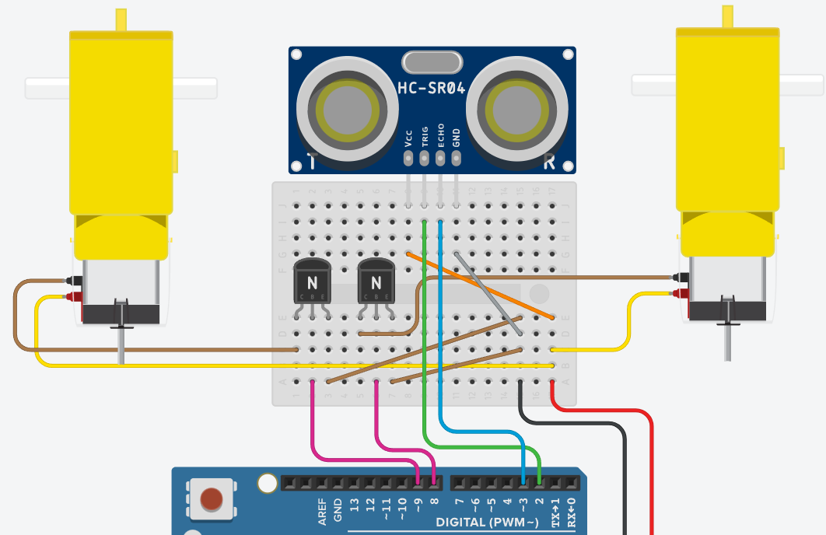

—--------------------------------------------------------------------------------

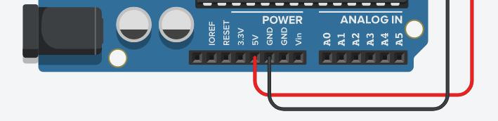

int motorRight = 8;

int motorLeft = 9;

int sensorTrig = 2;

int sensorEcho = 3;

float lastDistance = 1000; // The previous distance measured

int turnMotor = motorRight; // Which wheel should turn

void setup() {

pinMode(motorRight, OUTPUT);

pinMode(motorLeft, OUTPUT);

pinMode(sensorTrig, OUTPUT);

pinMode(sensorEcho, INPUT);

}

void loop() {

delay(50);

digitalWrite(sensorTrig, LOW);

delayMicroseconds(2);

digitalWrite(sensorTrig, HIGH);

delayMicroseconds(10);

digitalWrite(sensorTrig, LOW);

float duration = pulseIn(sensorEcho, HIGH);

float distanceInCm = duration / 29 / 2;

// This is to change the direction in case the rover turns

// and starts facing a wall:

if (distanceInCm < lastDistance) {

if (turnMotor == motorRight) {

turnMotor = motorLeft;

} else {

turnMotor = motorRight;

}

}

if (distanceInCm < 35) { // The distance could be adjusted

digitalWrite(motorRight, LOW);

digitalWrite(motorLeft, LOW);

digitalWrite(turnMotor, HIGH);

delay(250); // This gives short turns, in case the rover

// starts to run into a wall

digitalWrite(turnMotor, LOW);

} else {

digitalWrite(motorRight, HIGH);

digitalWrite(motorLeft, HIGH);

}

lastDistance = distanceInCm;

}